**Name........................................................................ Stream.......................**



**End of term one assessments**

**Biology**

**S.2**

**2hours**

**Instructions**

**Attempt all questions in this paper**

**Answers to section A must be written in the spaces provided.**

**Answers to section B should be in the answer sheets provided.**

**Drawings should be done using pencils.**

**Section A is marked out of 20marks.**

**Section B is marked out of 40marks.**

**For examiners use only**

|  |  |  |  |
| --- | --- | --- | --- |
| **Section** | **Score** | **Initials** |  |
| **A** |  |  |  |
| **B** |  |  |  |

**Item 1**

Kapeeka farmers association have submitted their concern to nakaseke district agricultural officer about a certain disease that has attacked their cassava plantations and it has the following characteristics, rolled leaves ,rotten tubers,stunted growth.the farmers have been invited to be trained at the district.

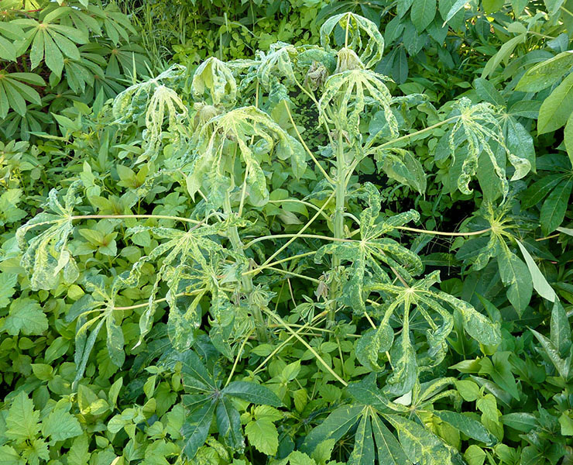

Task

As one of the district agricultural officials prepare assamary on how you are going to advice the farmers.

.,..........................................,...........................................................................................................................................................................

.,..........................................,...........................................................................................................................................................................

.,..........................................,..........................................................................................................................................................................

.,..........................................,...........................................................................................................................................................................

.,..........................................,.......................................................................................................................

**Item2**

The following data was obtained from an experiment on the effect of light intensity on the rate of photosynthesis

|  |  |  |  |  |  |  |
| --- | --- | --- | --- | --- | --- | --- |
| Number of gas bubbles per minute | 15 | 10 | 6 | 4 | 2 | 1 |
| Distance of the test tube from light source | 10 | 20 | 40 | 60 | 80 | 100 |

Task

Analyse the results and give an account for the results obtained.



....................................................................................................................................................................

....................................................................................................................................................................

....................................................................................................................................................................

....................................................................................................................................................................

....................................................................................................................................................................

....................................................................................................................................................................

....................................................................................................................................................................

....................................................................................................................................................................

....................................................................................................................................................................

**Section B(40 marks)**

Item 3

In a school management committee meeting, members resolved to prioritize learners health. They decided to include fish, fruits and corn flour on the students menu on addition to rice and beans. Learners age and weight were also to be monitored while they were in school. All students using laxatives and appetite boosting drugs were to be suspended from school. This communication was to be presented by the head prefect to the learners during the assembly held every monday.

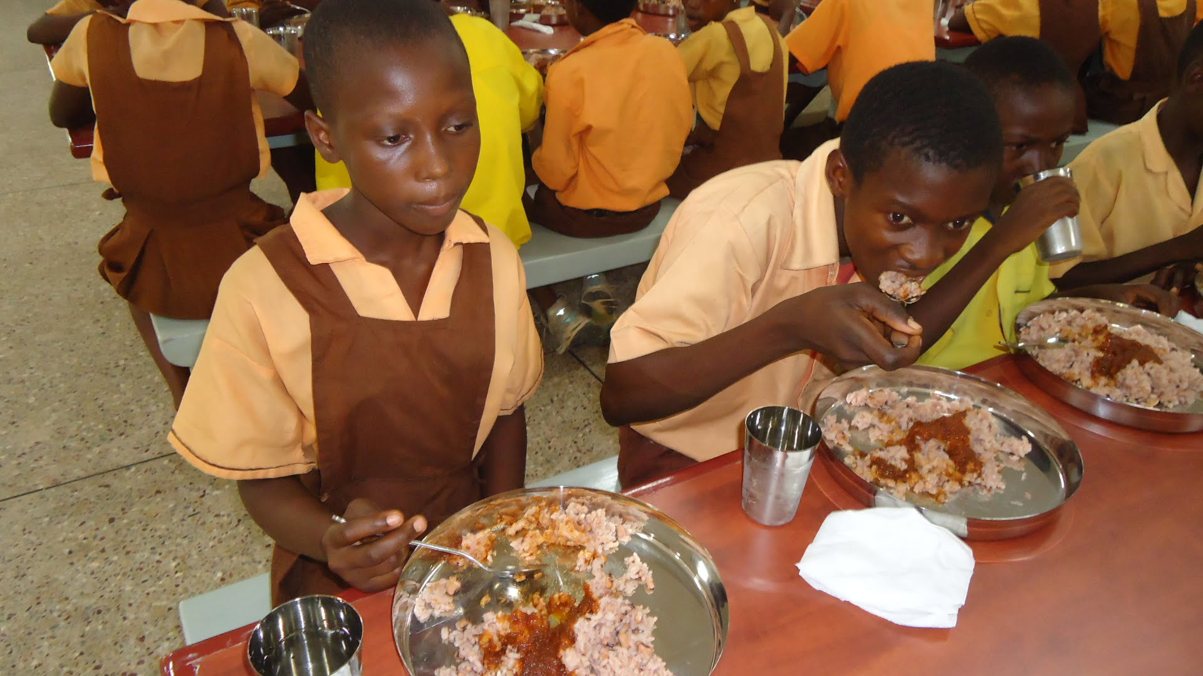

Task

Assuming u were the head prefect of the school , write an explanation you would give to the learners.

**Item4**

The ministry of health in Uganda has a program on vectors and disease control around lake regions. The most recent was on treated net distribution. The ministry explains that the prevalence and spread of the associated disease would be partly solved by treated nets.

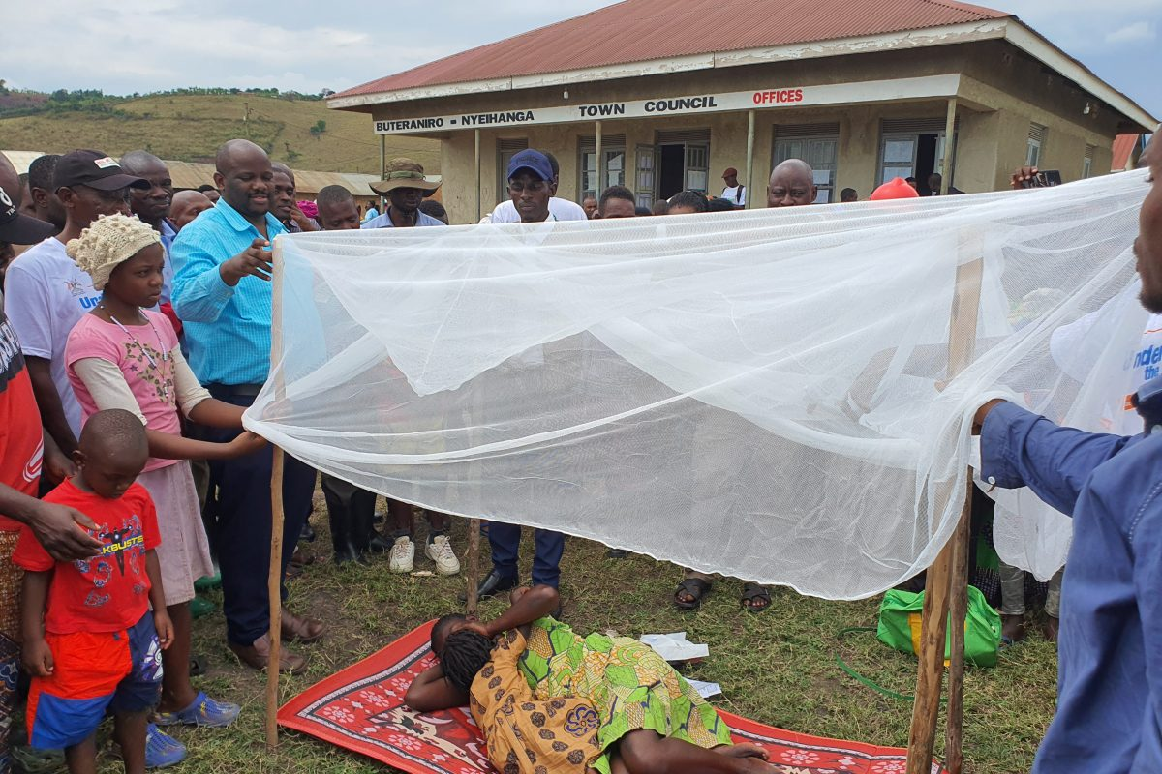

Task

The ministry also plans to have a sensitisation campaign in the communities, write a speech that will be delivered by the ministry during the compaign